Trading strategy:

We formed an equally weighted portfolio for 7 securities and rebalance them every year. The rebalancing strategy is based on the textual analysis on companies 10-K:

We first calculate the sentiment indicator (the percentage of positive words and negative words.) for each securities by analyzing company’s 10-K, then we run CAPM regression against 3 day CAR (cumulative abnormal return) to see if these sentiment indicator has power to explain the CAR (which is actually the difference between actual return and expected return). The analysis result is shown below:

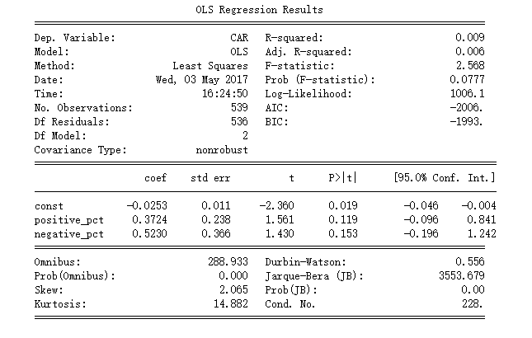

Based on the CAR analysis, we can see that the coefficient of positive words indicator is 0.3724 and 0.5230 for negative words indicator. Alpha is -0.0253.

The strategy is to rebalance the portfolio based on the model given above. Each year, we will analyze the 10-K to calculate CAR for each securities. We will long securities which has Higher CAR and short those which lower CAR than what model tells us.